Our assumption is that Balance Sheet accounts will be used to create the cash flow lines.

In that case debits decrease cash and credits increase cash, so we always multiply by -1 for Balance Sheet accounts.

Our assumption is also that when a P & L account is used, it is being used to "add back", in which case its sign shouldn't be reversed. (TAH thinks this assumption is a bit "iffy" because it's possible to build your cash flow lines using P & L accounts. However, we will say that our standard Cash Flow Statements assume you'll use Balance Sheet accounts except to "add back".)

Assets = Liabilities + OE
Cash + Non-cash Assets = Liabilities + OE
Cash = Liabilities + OE - Non-cash Assets

Therefore

when a liability goes up (is credited), cash goes up
when a non-cash asset goes up (is debited) cash goes down

Disposing of an asset doesn't affect cash. Therefore, we need to add back to the asset accounts the asset dispositions.

Selling an asset (i.e., receiving proceeds as part of the disposition) does affect cash. The proceeds are to be reported under Investing Activities.

When an asset is sold the proceeds need to debit an account, such as AR - Fixed Assets, that should be credited when the cash is posted via Bank Deposits. To make the cash flow statement correct, we need to pick up only the credit (which will show as positive proceeds on the cash flow because we reverse the signs on balance sheet accounts) not the debit. Therefore, we'll add back the debit created by the disposition FA document.

For example, asset 000021 which had an original cost of $600 and $10 of accumulated depreciation was sold for $450 when it had a book value of $590. The disposition posted as

Debit EF1590 Accumulated Depreciation $10
Debit EF1130 AR - Fixed Assets (proceeds pending) $450
Debit 2108410 Gain/Loss on Sale $140
Credit EF1530 Equipment $600

The bank deposit posted as

Debit EF1020 Cash $450
Credit EF1130 AR - Fixed Assets (proceeds pending) $450

We need to remove the $600 credit from EF1020 for Cash Flow reporting purposes.

We need to remove the $450 debit from EF1130 for Cash Flow reporting purposes.

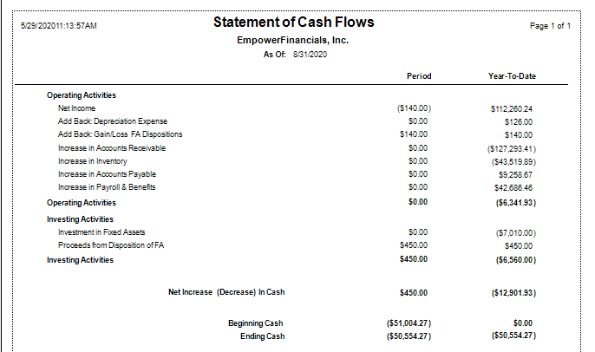

Cash Flow lines for add backs.

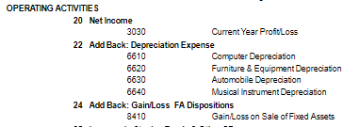

Cash flow lines for Investing Activities.

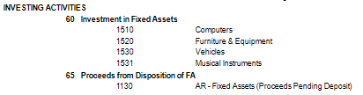

Disposition JE

